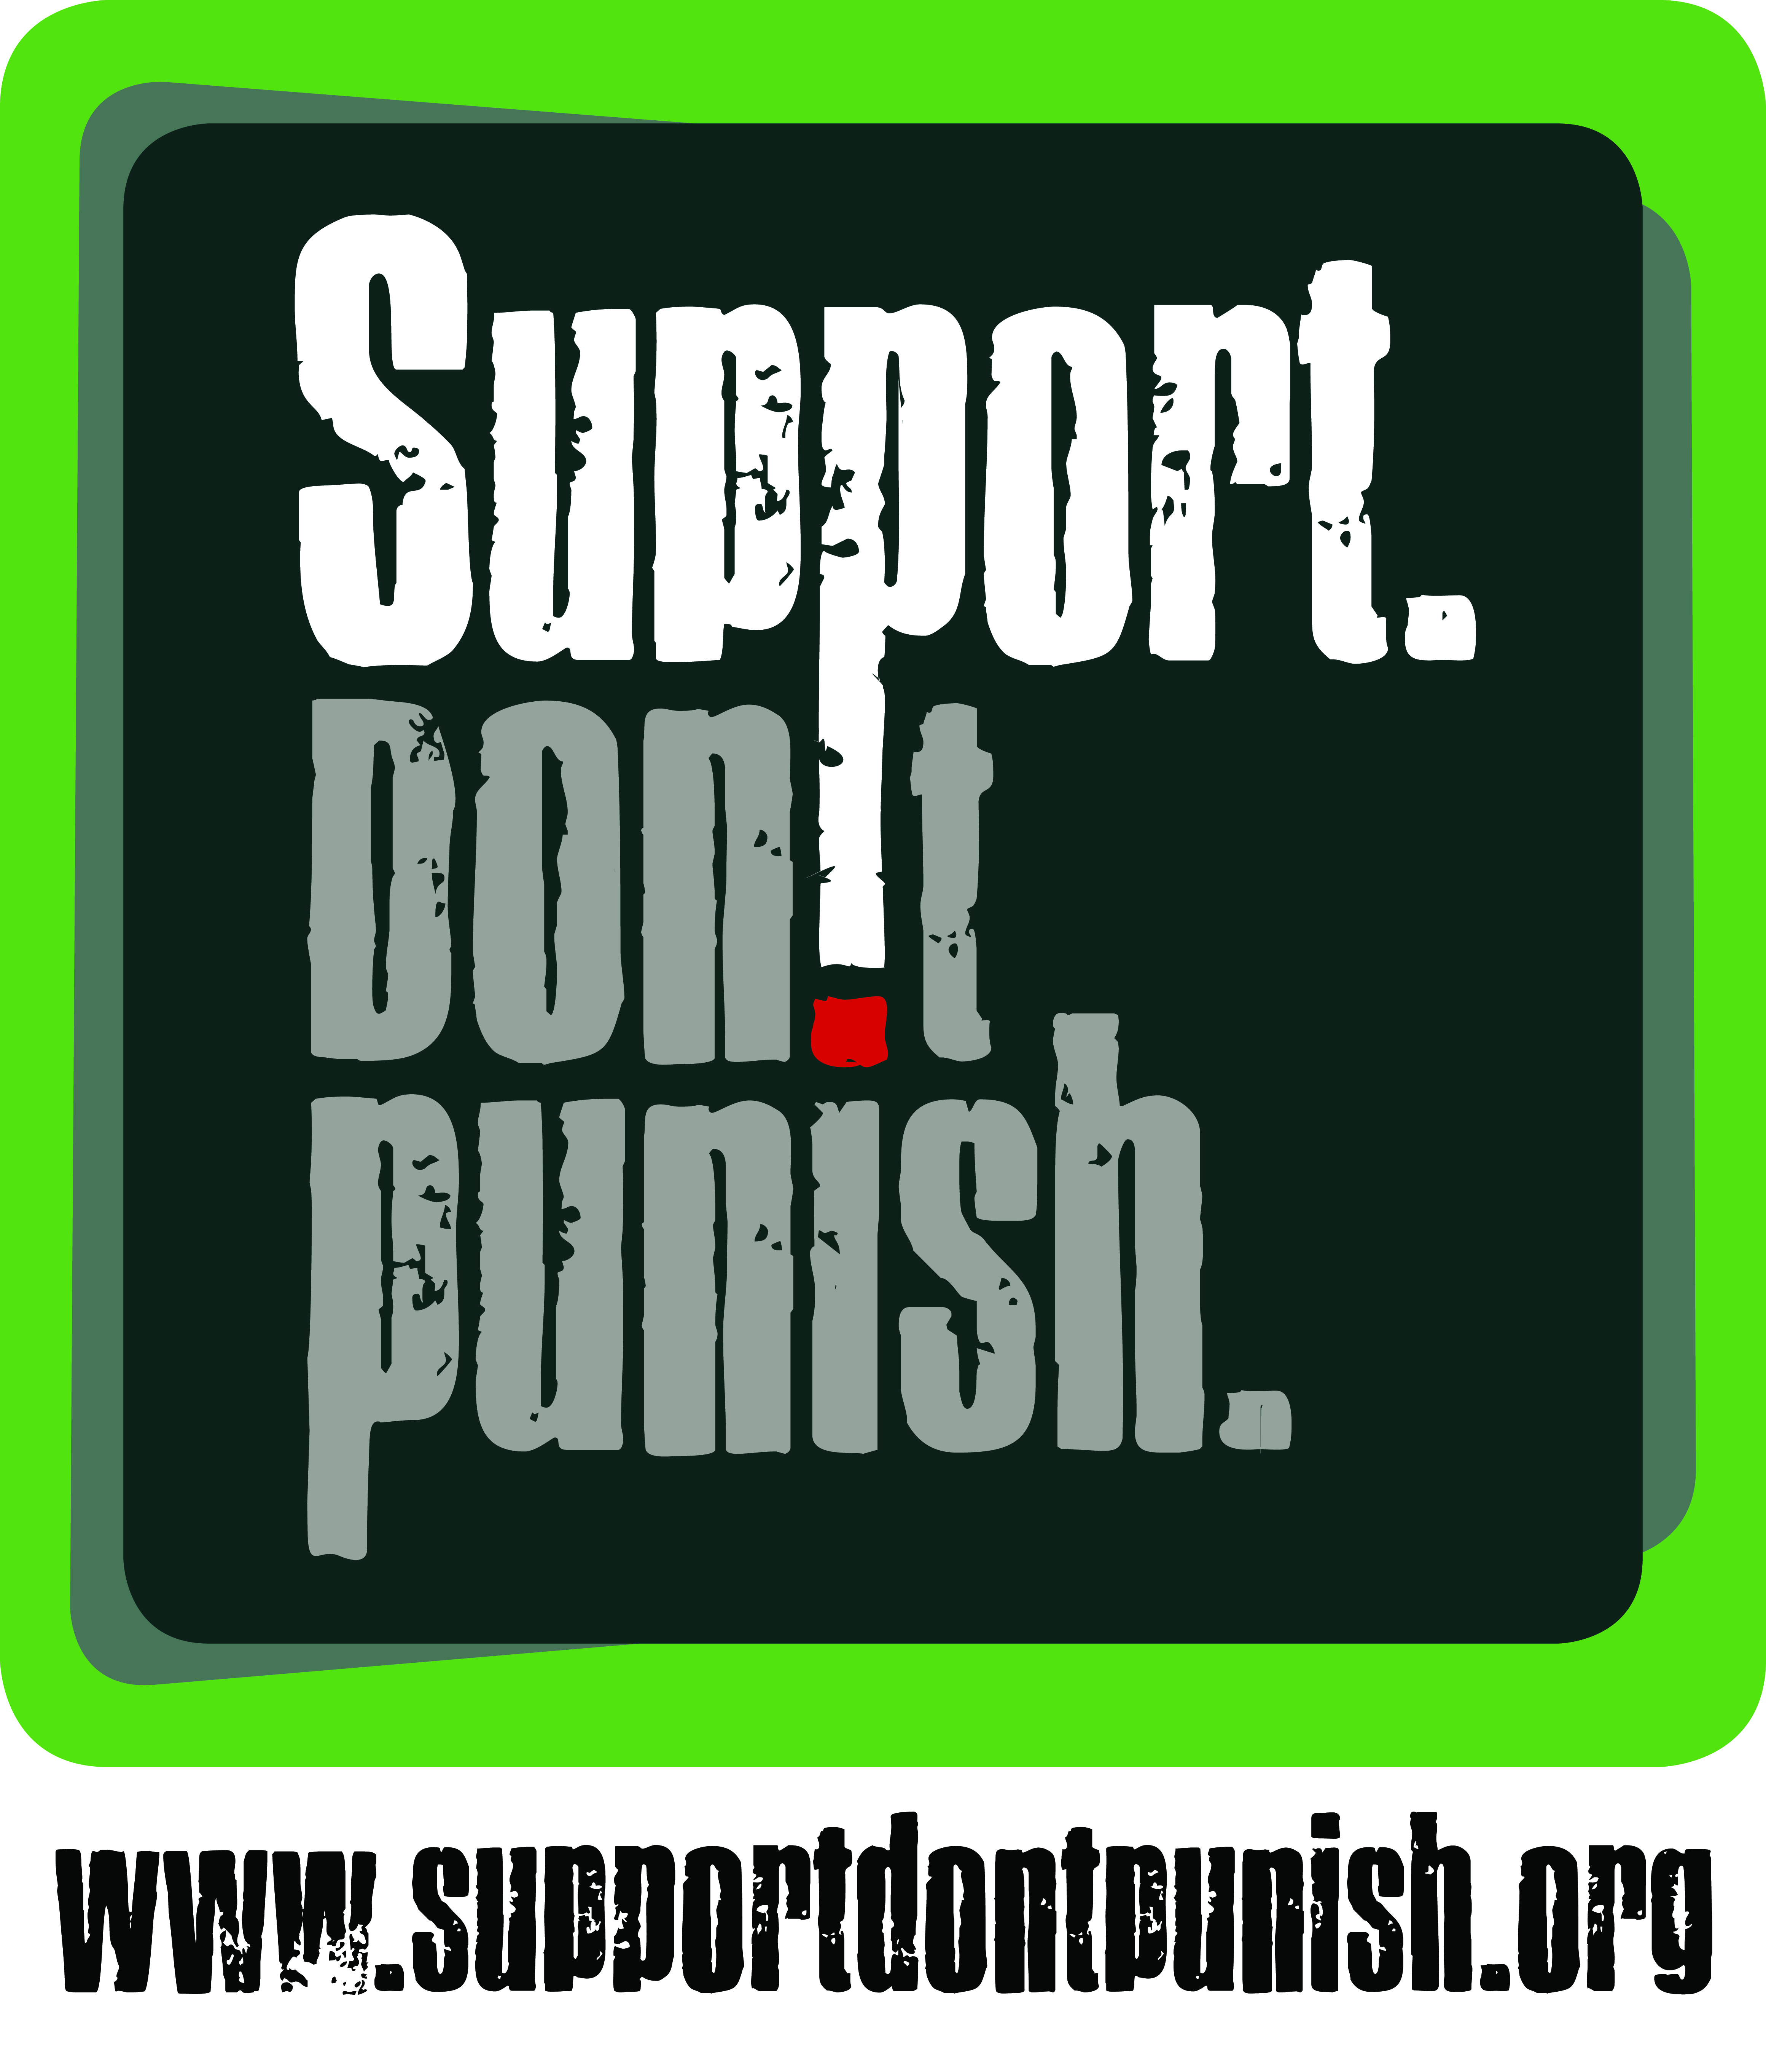
This letter is designed to help you engage local partners in the campaign. Please feel free to adapt it as needed, and replace the text in yellow (and delete this text too!).

Name
Title
Address
Address
Address
Address

Date

Re: Invitation to engage in the ‘Global Day of Action’, 26th June 2015

Dear Name,

On Friday 26th June 2015, more than 100 cities around the world will be holding actions to highlight the harm that is being caused by the war on drugs. This will take place as part of the global “Support. Don’t Punish” campaign – which aims to promote harm reduction, call for policy reform, call for better funding for health services, and promote the removal of criminal sanctions for people who use drugs and other low-level drug offenders.

Add paragraph about your plans: where, when and what. For example:
In London, IDPC and partners are planning a public gathering outside of the Houses of Parliament. We anticipate around 200 participants will attend, each person wearing special Support. Don’t Punish t-shirts, and we will hand a petition to the Prime Minister calling for drug law reforms.
[Add a link to your webpage or Facebook page for the event, if there is one]

I am writing today to invite [organisation or individual] to be a part of this campaign, and to join us as we plan the event for 26th June. Your ideas, expertise and support would be a major boost to the campaign, and will help us to attract even greater media interest on the day.

You can find out more about the global campaign at www.supportdontpunish.org, and if you send your logo to campaign@idpc.net, they can also add you to the global list of supporters (featured on Facebook and http://supportdontpunish.org/supporting-ngos/). You can also take a photo of you and your colleagues with the campaign logo, and send it to campaign@idpc.net for inclusion in the ‘Interactive Photo Project’ (http://supportdontpunish.org/photoproject/).

If you would like to discuss this further, please contact me on [insert phone numbers and/or email address].

Yours sincerely,

[Sign-off]

