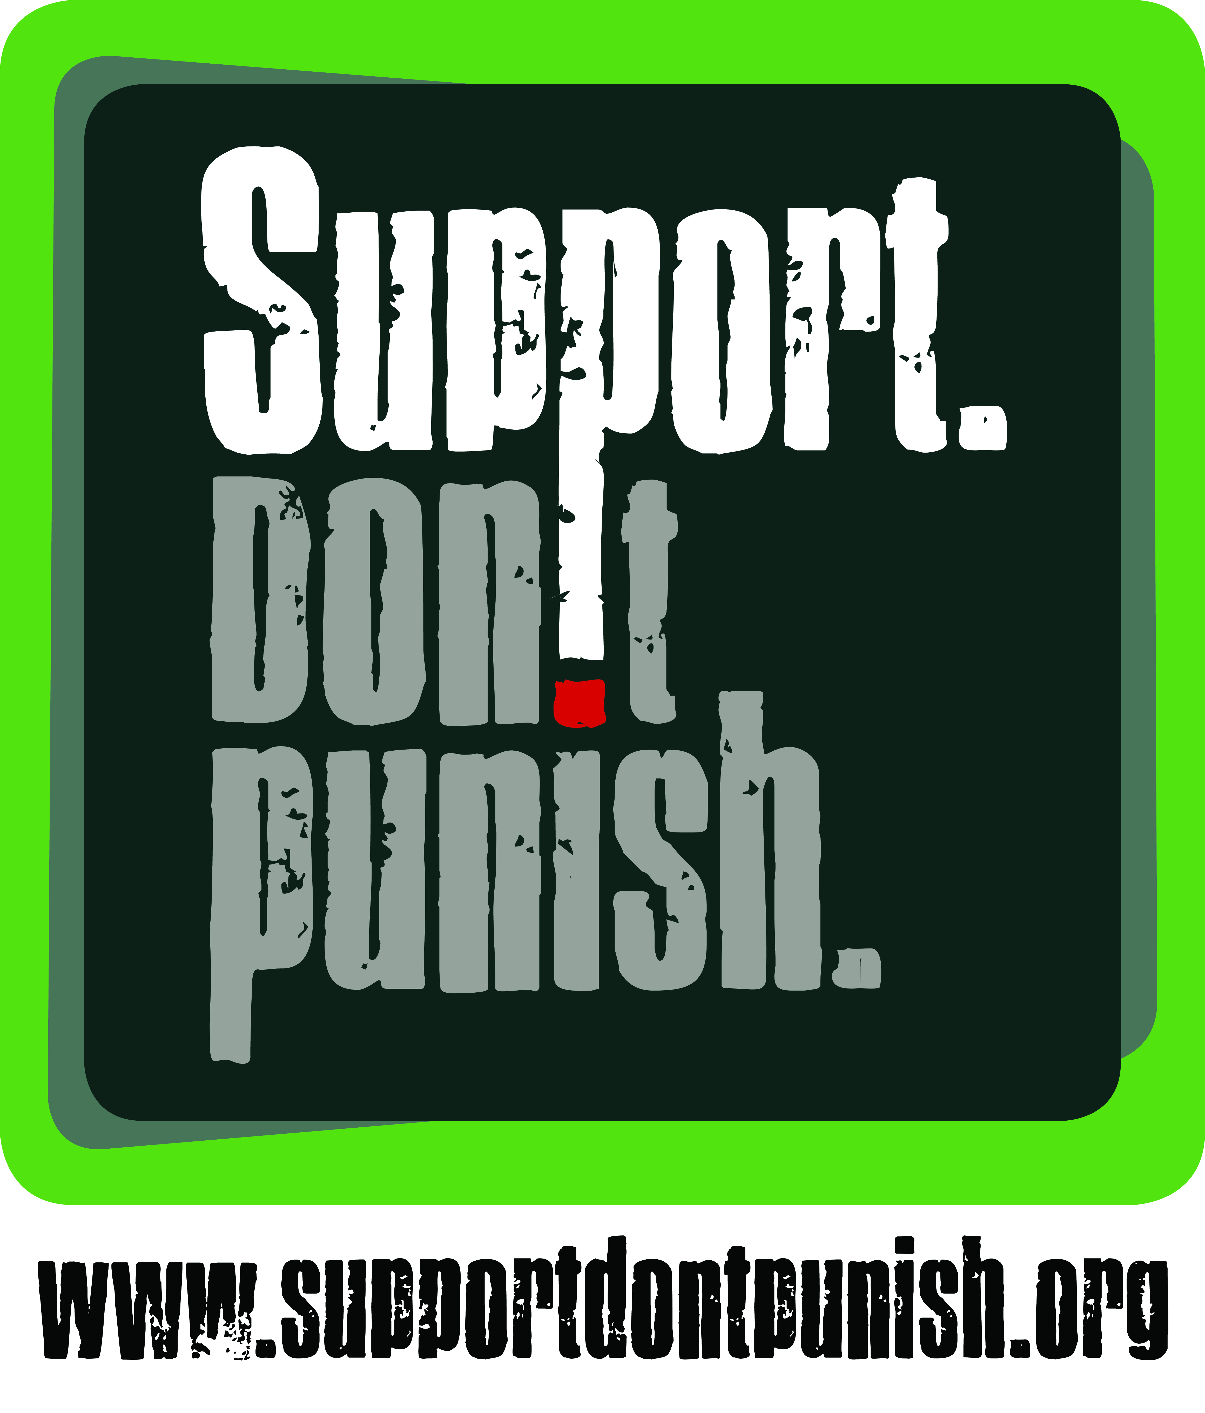 | URGENT MEDIA RELEASE  Activists in more than 150 cities take to the streets to protest against the war on drugs

[Add City], 26th June 2015

[Open with a short description of your event – for example:
Today in London, a hundred activists will gather outside of the Houses of Parliament to call for a review of the UK’s drug laws.]

[City] is one of more than 150 cities from across Europe, Asia, Africa and the Americas in which activists will make their voices heard as part of the global “Support Don’t Punish” campaign. The campaign calls on governments to put an end to the expensive and counter-productive war on drugs. Thousands of people will be taking to the streets as part of a global show of force calling for more humane and effective drug policies.

Today is significant as it is the United Nations’ International Day against Drug Abuse and Illicit Trafficking – a day when governments typically celebrate drug arrests and drug seizures. In the past, some governments have even commemorated this day by holding public executions or beatings of drug offenders. Yet this is all part of a global war on drugs that, by the United Nations’ own admission, has failed to reduce drug use and has led to serious negative consequences

Today is also the International Day in Support of Victims of Torture, as well as the 70th anniversary of the signing of the founding Charter of the United Nations, which sought to “reaffirm faith in fundamental human rights, in the dignity and worth of the human person”. The irony is that the war on drugs has been used to justify widespread human rights violations including torture, arbitrary detention, abuse and the death penalty.

[You can use this paragraph, or replace it with local data or issues, if appropriate:
At the same time, the war on drugs has failed to reduce drug use or supply, yet it continues to cost in excess of $100 billion each year to enforce. It has led to the mass incarceration of vulnerable and poor people across the world, and fuels epidemics such as HIV, hepatitis and tuberculosis. It has directly resulted in a multi-billion dollar black market for “controlled” drugs, and diverted attention and funding away from effective public health approaches to the problem.]

Ann Fordham, Executive Director of the International Drug Policy Consortium (IDPC) which oversees the global campaign, said “Today, thousands of people from over 150 cities will take part in this global day of action. This is yet another demonstration of the growing call for better drug policies. Enough is enough, we have to support, not punish, people who use drugs. It is time to end the war on drugs”.

[Add a local quote – ideally from a high-profile person from the city/country]

******
NOTES TO EDITOR:

ABOUT THE CAMPAIGN

The “Support Don’t Punish” campaign is a global initiative calling for investments in proven effective and cost-effective harm reduction responses for people who use drugs, and for the decriminalisation of people who use drugs, and the removal of other laws that impede public health services. The campaign was launched in 2013 – as an initiative of the International Drug Policy Consortium (IDPC), the International Network of People who Use Drugs (INPUD), Harm Reduction International (HRI), and the International HIV/AIDS Alliance. On 26th June 2013, 41 cities participated in the Global Day of Action. On 26th June 2014, events were held in 100 cities – including street performances, street art, protests, music events, football tournaments, processions, and even a boat show in the Nile!

This year, actions are planned to take place in Australia, Brazil, Egypt, India, Mexico, Nigeria, Russia, Thailand, Ukraine, the United Kingdom, and the USA – as well as in Argentina, Belgium, Benin, Bolivia, Bulgaria, Burkina Faso, Burundi, Cambodia, Canada, Colombia, Costa Rica, Denmark, France, The Gambia, Georgia, Ghana, Greece, Hungary, Indonesia, Ireland, Ivory Coast, Jordan, Kazakhstan, Lebanon, Liberia, Lithuania, Macedonia, Malawi, Malaysia, Mali, Moldova, Montenegro, Myanmar, Nepal, New Zealand, Niger, Norway, Philippines, Poland, Portugal, Puerto Rico, Romania, Serbia, Senegal, Sierra Leone, Slovakia, Spain, Switzerland, Tajikistan, Tunisia, Uruguay, Uzbekistan and Zimbabwe!

For more information and resources about the campaign, visit www.supportdontpunish.org and http://supportdontpunish.org/day-of-action-2015/

ABOUT THE EVENT IN [CITY]

Where: [EXACT LOCATION, IF POSSIBLE]
When: [EXACT TIMES, IF POSSIBLE]
What: [ENTER MORE DETAILS ABOUT THE ACTION, INCLUDING FACEBOOK LINKS]

CONTACTS FOR FURTHER INFORMATION:

[CITY] ENQUIRIES:  [ENTER NAME]  [ENTER ORGANISATION NAME]  [ENTER EMAIL ADDRESS]  [ENTER MOBILE NUMBER]  [ENTER TWITTER / FACEBOOK / SKYPE NAMES AND LINKS] | GLOBAL ENQUIRIES:  Jamie Bridge  International Drug Policy Consortium  jbridge@idpc.net  +44 207 324 2996  Skype: bridgejamie  www.facebook.com/supportdontpunish  Twitter: @SDPcampaign

